Plant metallothioneins as potential players in food security
Marie Sklodowska-Curie Individual Fellowship conducted within the
Horizon 2020 programme (Grant No. 701492-PMTFOS)

Project realised in the Department of Chemistry University of Warwick under the supervision of Dr. Claudia A. Blindauer and in collaboration with Dr. Jose Gutierrez-Marcos from School of Life Sciences University of Warwick

One of the most important challenges nowadays, in the face of a growing world population, is complex issue of food security that is defined as the availability of sufficient amount of nutritious food for everybody, produced in sustainable way. There are numerous factors threating food security including declines in water supplies and more often and more severe drought events. On the other hand, 2 billion people worldwide suffer from “hidden hunger” caused by micronutrient deficiency that leads to serious health problems. Among multiple micronutrients that are essential for all life, the importance of zinc has recently come to the fore. Zinc is involved in almost every metabolic process and thus, the effects of zinc deficiency are serious and multifactorial. WHO estimates that deficiency of only this single micronutrient leads to the death of almost 0.5 million children every year. Cereals including wheat, barley, maize, rice, rye, oats and sorghum are important source of food worldwide but the bioavailability of zinc (and also iron) from gains is very limited. In developing countries where diversification of diet (more fish and meat) is rather unrealistic efforts are needed to improve the content/bioavailability of zinc in staple plants. Long-term and cost-effective biofortification strategies should base on improvement of plant cultivars rather than on application of trace elements into soil. In order to achieve this the mechanisms underlying micronutrients transport, accumulation and storage needs to be thoroughly understood.
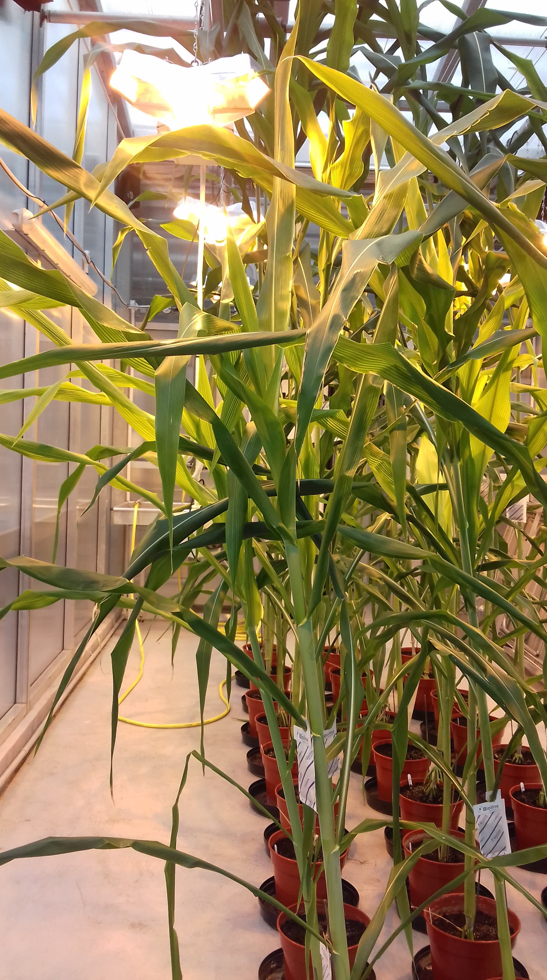Sorghum bicolor plants grown in glasshouse
The aim of my project is to evaluate o role of metallothioneins (MTs) in zinc accumulation in edible parts of plants and in drought stress tolerance. In my work I concentrate on Sorghum bicolor (great millet), a crop with remarkable drought resistance. Sorghum is widely grown in arid and semi-arid region of Africa where is a major dietary staple for more than 500 million people. It is also widely grown in Asia, America and the Indian subcontinent for its fibre, fuel and ethanol production. In addition, sorghum is an attractive candidate for biofortification purpose because it is widely cultivated in regions of the world where micronutrients malnutrition is the most severe. During my project I wanted to answer the questions whether sorghum MTs are involved in zinc accumulation and discrimination between essential zinc and highly toxic cadmium. To address this question a unique cross-disciplinary approach was used. The knowledge generated in my project offers the promise to enable the development of crop plant cultivars which will combine high yield, obtained even in adverse environmental conditions, with high nutritional value.
Sorghum metallothionein proteins were analysed using mass spectrometry, elemental analysis, UV-Vis spectroscopy and state-of-art nuclear resonance spectroscopy. It was shown that among all sorghum metallothioneins only one seed-specific type 4 MT (SbMT4) is genuine Zn-thionein and may be involved in zinc accumulation in seeds. In addition, transgenic plants that overexpressed sorghum MT type 4 were generated. It was shown that those transgenic plants accumulated more cadmium in roots but did not show enhanced tolerance towards this toxic metal. Interestingly, plants expressing mutated version of SbMT4 are not only able to accumulate more cadmium in shoots but also are more resistant to cadmium.
Future translation of the fundamental insights into metal accumulation mechanisms in plants gathered during realisation of this project will lead to novel biofortification strategies for cereal. The obtained results revealed the metallothioneins are one of the crucial elements involved into sophisticated network of metal accumulation in edible part of plants including grains. However, the potential role of seed-specific type 4 metallothionein in discrimination between zinc and cadmium is less certain. Although, type 4 MTs are very similar in different even evolutionary distant plant species it seems that biochemical characterization is of each protein is needed.
News
https://horizon-magazine.eu/article/boosting-nutrients-crops-beat-hidden-hunger-poor-diet.html
http://naukawpolsce.pap.pl/aktualnosci/news%2C408620%2Csorgo-w-czasie-suszy-bialka-strzegace-przed-usychaniem.html

Useful links
Marie Sklodowska Curie Fellowships
https://ec.europa.eu/research/mariecurieactions/actions/individual-fellowships_en
Horizon2020
https://ec.europa.eu/programmes/horizon2020/en
Micronutrient malnutrition
http://www.fao.org/3/x0245e/x0245e01.htm
https://www.cdc.gov/nutrition/micronutrient-malnutrition/index.html
Zinc deficiency
https://www.who.int/publications/cra/chapters/volume1/0257-0280.pdf
https://www.who.int/elena/bbc/zinc_stunting/en/
Sorghum
https://hort.purdue.edu/newcrop/duke_energy/Sorghum_bicolor.html

